

**Computer Organization and Assembly Language**

**Yasser Mohamed mamoun**

**Section 8**

**Computer Science**

Quiz 1 20/2/2020

In the Hypothetical Machine the contents of memory was as shown. And PC contents is 300. Show the contents of memory and PC, AC, IR after execute three instructions (three fetch cycle and there execute cycle)

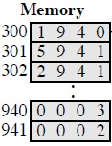

|  |  |  |  |
| --- | --- | --- | --- |
| **ANSWER:**  First Instruction:  • Fetching: | |  |  |
| AC: | 0000 IR: 1940 | PC: | 300 |
| 940: | 0003 941: 0002 |  |  |
| • | Execution: |  |  |
| AC: | 0003 IR: 1940 | PC: | 300 |
| 940: | 0003 941: 0002 |  |  |
| Sec  • | ond Instruction:  Fetching: |  |  |
| AC: | 0003 IR: 5941 | PC: | 301 |
| 940: | 0003 941: 0002 |  |  |
| • | Execution: |  |  |
| AC: | 0005 IR: 5941 | PC: | 301 |
| 940: | 0003 941: 0002 |  |  |
| Third Instruction:  • Fetching:  AC: 0005 IR: 2941 | | PC: | 302 |
| 940: 0003 941: 0002  • Execution:  Ac: 0000 IR: 2941 | | PC: | 302 |
| 940: 0003 941: 0005 | |  |  |

Show the contents of PC , AC and IR and memory after the execution of each instruction of the following program on the Hypothetical Machine:

1. LOAD 550
2. ADD 551
3. STORE 600

.Where the contents of memory at 550 is 3 and at 551 is 4

|  |  |  |  |  |
| --- | --- | --- | --- | --- |
| **ANSWER:-**  First Instruction:  • Fetching: | | |  | |
| AC: | 0000 IR: 1550 | | PC: | 300 |
| 550: | 0003 551: 0004 | | 600: | 0000 |
| • | Execution: | |  |  |
| AC: | 0003 IR: 1550 | | PC: | 300 |
| 550: | 0003 551: 0004 | | 600: | 0000 |
| Sec  • | ond Instruction:  Fetching: | |  |  |
| AC: | 0003 IR: 5551 | | PC: | 301 |
| 550: | 0003 551: 0004 | | 600: | 0000 |
| • | Execution: | |  |  |
| AC: | 0007 IR: 5551 | | PC: | 301 |
| 550: | 0003 551: 0004 | | 600: | 0000 |
| Third Instruction:  • Fetching:  AC: 0007 IR: 2600 | | | PC: | 302 |
| 550: 0003 551: 0004 | | | 600: | 0000 |
| • Execution:  AC: 0000 | | IR: 2600 | PC: | 302 |
| 550: 0003 551: 0004 | | | 600: 0007 | |

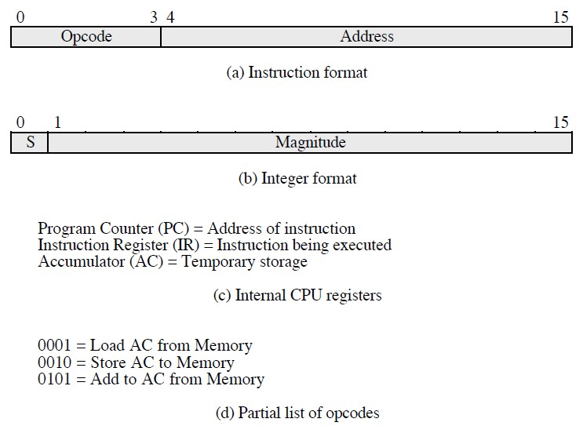

The following figure provide the main characteristics of

.Hypothetical Machine The hypothetical machine also has two I/O instructions:

0011 = load AC from I/O

0111 =store AC to I/O

In these case, the 12-bi address identifies a particular I/O device. Show the program execution for the following program:

1. Load AC from device 5.
2. Add contents of memory location 940.
3. Store AC to device 6.

Assume that the next value retrieved from device 5 is 3 and that location 940 contains a value of 2.

ANSWER:

MEMORY

300

3005

301

5940

302

7006

After executing the three instructions:

device 5:

0003

940:

2

device 6:

0005